**Experiment 1**

**PART A**

**A.1 Aim**

*To understand the trouble of interacting with E-Commerce websites – Amazon and Flipkart.*

**A.2 Prerequisite**

Understanding of basic knowledge of interface about websites and their usage.

**A.3 Outcome**

After experimentation, students will be able:

* To understand the importance of human psychology in designing of good interfaces
* To understand the concepts of designing as per user centered and interaction process

**A.4 Theory**

Interaction design is a process of providing an interaction between users and products. Most often when people talk about interaction design, the products tend to be software products like apps or websites. The goal of interaction design is to create products that enable the user to achieve their objective(s) in the best way possible. Sometimes, it is called User-cantered design (UCD) which is an iterative design process in which designers focus on the users and their needs in each phase of the design process. In UCD, design teams involve users throughout the design process via a variety of research and design techniques, to create highly usable and accessible products for them.

**Fundamentals principles of interactions:**

1. **Discoverability** - How is the product is supposed to be used? What are the possible actions and how to perform them? When we interact with a product, we need to figure out how to work it
2. **Understanding** - How is the product supposed to be used? What do all different controls and settings?
3. **Affordance** — Relationship between the properties of an object and the capabilities of the agent that determine just how the object could possibly be used.
4. **Signifiers** — Communicate where the action should take place.
5. **Mappings** — The relationship between the elements of two sets of things. Mapping gives the relationship between control and displays.
6. **Feedback** —Communicating the results of an action

**A.5 Tasks to perform**

1. Perform all the operations to buy any electronic product from the ecommerce websites like Amazon and Flipkart. Identity which website is taking more actions and time to execute the entire operations and why? (paste the screen shot wherever is applicable)
2. Keep in mind all the interaction principles while ordering the product and fill the tick  and  symbols in the following table wherever is applied otherwise leave it blank (---)

|  |  |  |
| --- | --- | --- |
| Principles | Websites | |
| Amazon | Flipkart |
| Discoverability |  |  |
| Understanding |  |  |
| Affordance |  |  |
| Signifiers |  |  |
| Mappings |  |  |
| Feedback |  |  |

1. As per the above table, give reasons to choose the symbols. Students are supposed to write the reasons at what point websites are following principles of interaction and not.

**(PART - B)**

(TO BE COMPLETED BY STUDENTS)

(Students must submit the soft copy as per following segments within two hours of the practical)

|  |  |
| --- | --- |
| Roll. No. : A016,A018,A022 | Name: Varun K, Simran K, Kartik P |
| Sem/Year : VII/4 | Batch: 1 |
| Date of Experiment : 22/07/2022 | Date of Submission:22/07/2022 |
| Grade -- |  |

**B.1: Output of performed tasks**

1. Perform all the operations to buy any electronic product from the ecommerce websites like Amazon and Flipkart. Identity which website is taking more actions and time to execute the entire operations and why? (paste the screen shot wherever is applicable)

# AMAZON

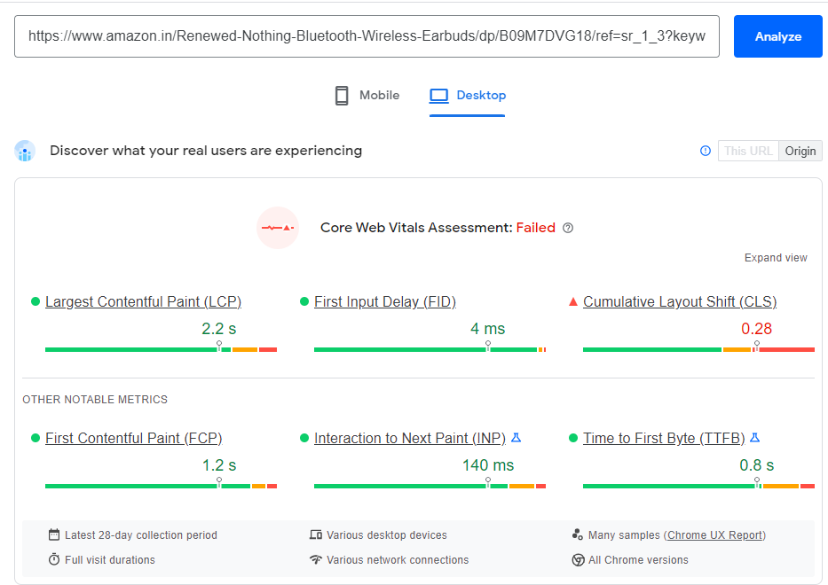

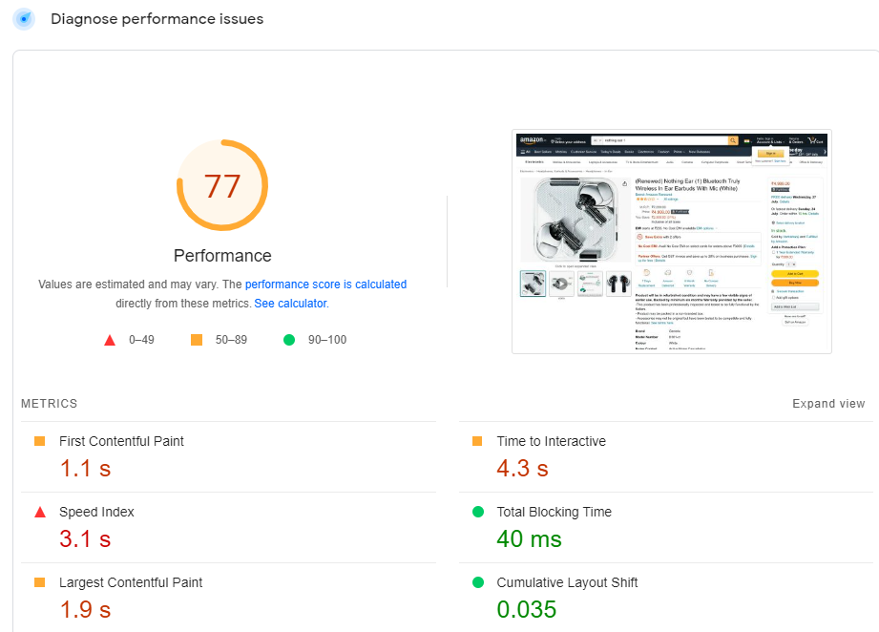

# FLIPKART

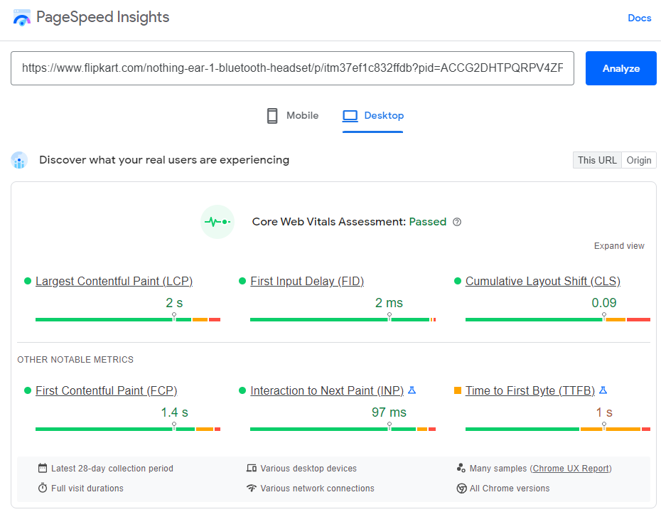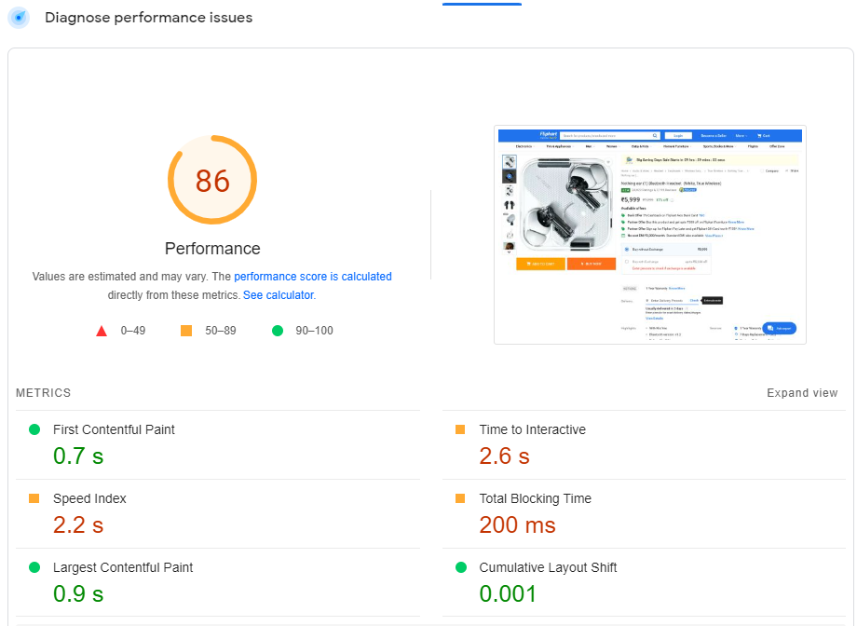

1. Keep in mind all the interaction principles while ordering the product and fill the tick  and  symbols in the following table wherever is applied otherwise leave it blank (---)

|  |  |  |
| --- | --- | --- |
| Principles | Websites | |
| Amazon | Flipkart |
| Discoverability |  |  |
| Understanding |  |  |
| Affordance |  |  |
| Signifiers |  |  |
| Mappings |  |  |
| Feedback |  |  |

1. As per the above table, give reasons to choose the symbols. Students are supposed to write the reasons at what point websites are following principles of interaction and not.

# Discoverability

Items are mostly discoverable on home page in case of Flipkart. However, for Amazon all options are in the hamburger menu in top left.

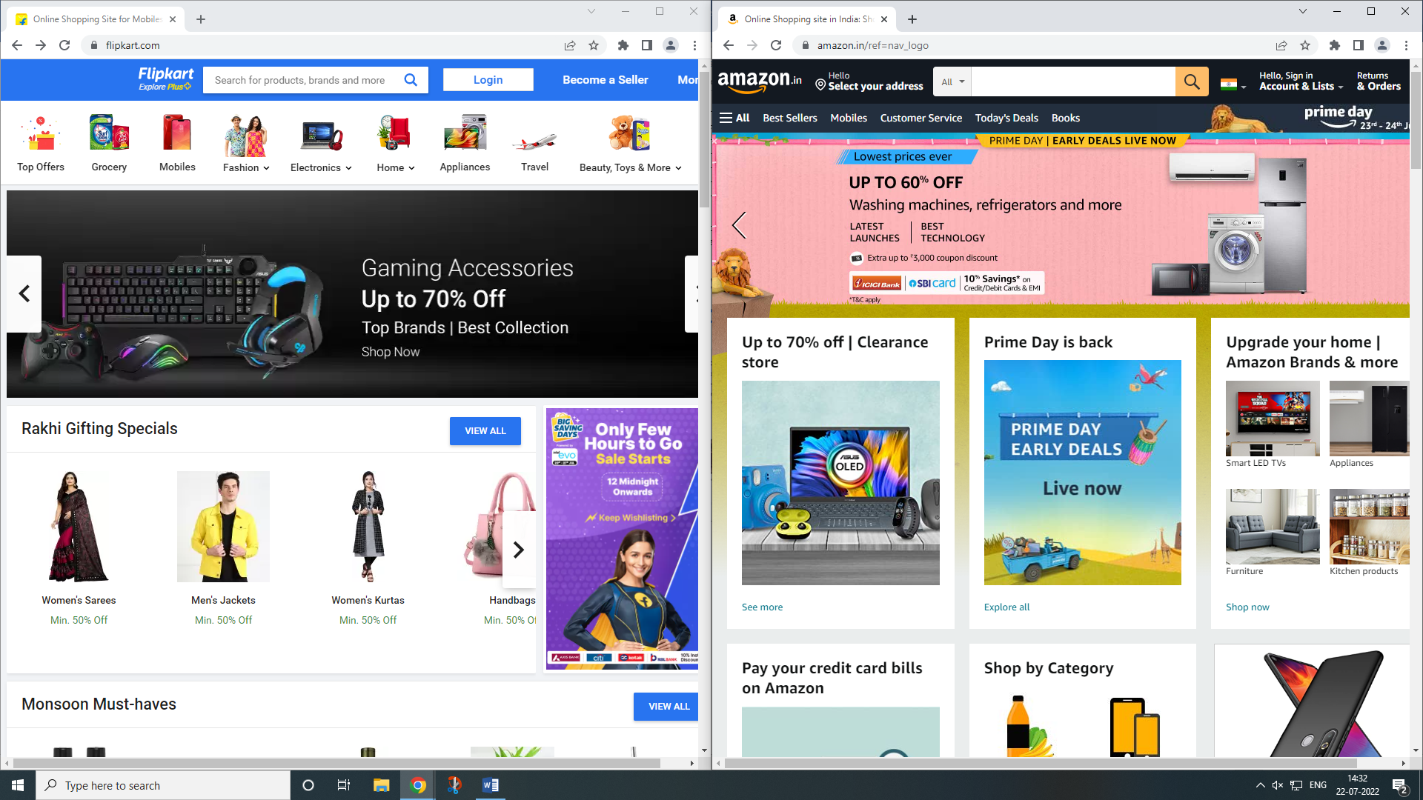

# Understanding

Product description on Amazon is much clearer and more detailed as compared to Flipkart.

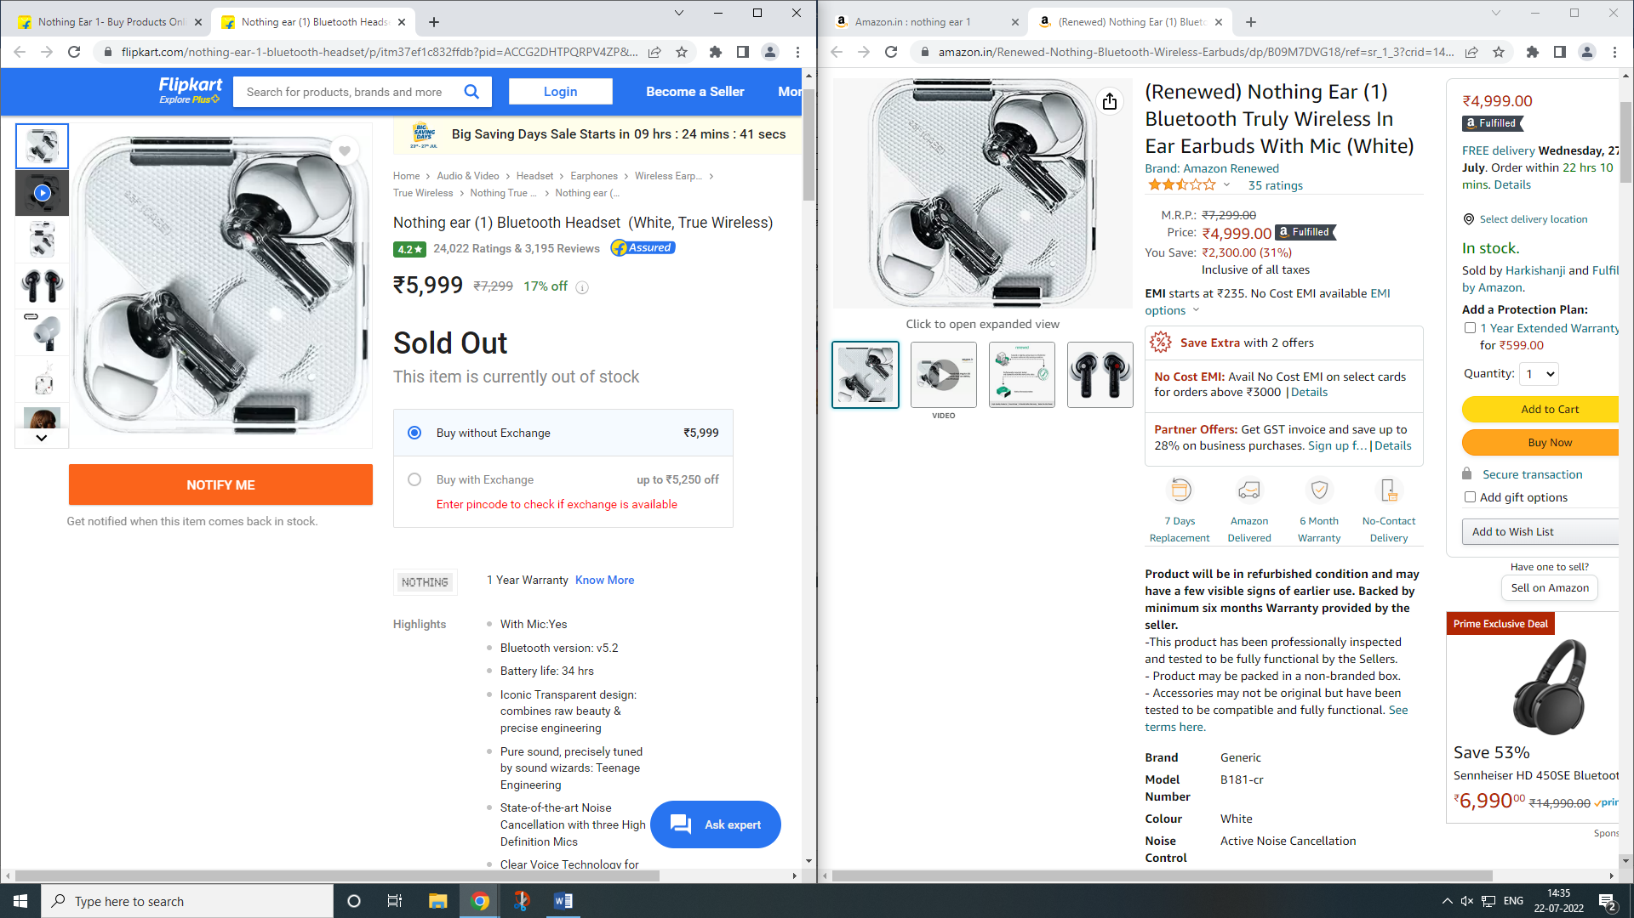

## Affordance

Relationship between the properties of an object and the capabilities of User can easily be mapped on Flipkart as compared to Amazon.

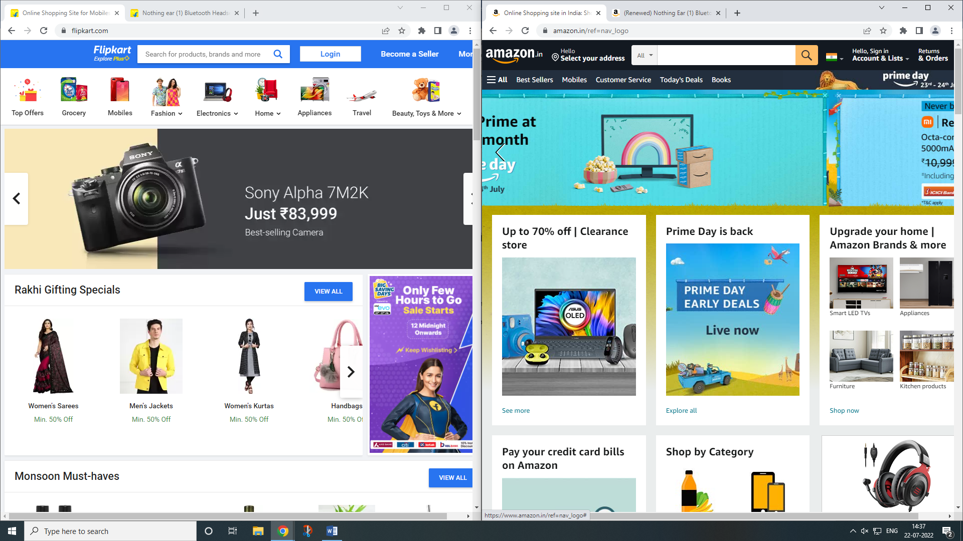

## Signifiers

Products on home page communicates well with users in terms of usability for Flipkart.



## Mappings

Symbols used to map a particular product on Flipkart is clear and understandable by user.



## Feedback

Response Time/Time to Interact with user on Flipkart is much faster as compared to Amazon.

**B.2: Observations and Learning’s:**

* In case of Flipkart navigation bar has dropdown menu of categories for all product which could be adopted by Amazon instead of the small hamburger menu at the top left of their page.
* On Amazon each product has a slide displaying the method to use, features etc. is displayed in a systematic order which is easily understandable by user whereas in Flipkart it is in a clustered form.

**B.3: Conclusion:**

Hence, from our analysis we can conclude that overall performance of Amazon is good but the performance of individual component in Flipkart is better in terms of user interaction.